**Step 1: Verify Master Branch is Clean**  
**Description:**  
Checked that the master branch has no uncommitted changes before starting the lab.  
**Commands Used:**

git log --oneline --graph --decorate --all

git status

**Step 2: Create and Switch to GitWork Branch**  
**Description:**  
Created a new branch GitWork from master and switched to it.  
**Commands Used:**

git checkout -b GitWork

echo "<greeting>Hello from GitWork branch</greeting>" > hello.xml  
echo "<message>Updated in GitWork branch</message>" >> hello.xml  
git status  
git commit -m "Added and updated hello.xml in GitWork branch"

**Step 3: Add hello.xml in GitWork**  
**Description:**  
Created hello.xml with unique content for the GitWork branch and committed the change.  
**Commands Used:**

git checkout master

git status

git commit -m "Added hello.xml in master branch"

**Screenshot(s):**

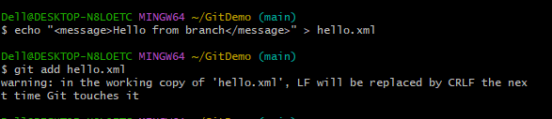

**Step 4: Switch to Master and Add hello.xml**  
**Description:**  
Switched back to master and created a different version of hello.xml, committing the change.  
**Commands Used:**

git log --oneline --graph --decorate --all

git diff master GitWork

git status

git config --global mergetool.p4merge.path "C:/Program Files/Perforce/p4merge.exe"

**Step 5: Merge and Trigger Conflict**  
**Description:**  
Merged GitWork into master, resulting in a merge conflict in hello.xml.  
**Commands Used:**

git add hello.xml  
git commit

**Step 6: Resolve Merge Conflict**  
**Description:**  
Opened hello.xml, manually resolved the conflict by combining both changes, removed conflict markers, and committed the result.  
**Commands Used:**

git status

rm hello_BACKUP_411.xml hello_BASE_411.xml hello_LOCAL_411.xml hello_REMOTE_411.xml  
git status  
git push

**Step 7: Update .gitignore**  
**Description:**  
Ignored backup files by adding a rule to .gitignore and committing the change.  
**Commands Used:**

git branch  
git branch -d GitWork

git log --oneline --graph --decorate

git push origin --delete GitWork

**Step 8: Delete GitWork Branch**  
**Description:**  
Deleted the merged GitWork branch.  
**Commands Used:**

git branch -d GitWork

**Step 9: View Commit History**  
**Description:**  
Viewed the commit history in a graphical format to confirm the merge and branch deletion.  
**Commands Used:**

git log --oneline --graph --decorate

**Screenshot(s):**

